Topic: System Planning and Process

Tripti Vishwakarma
Colorado State University Global
Course Code: CSC 501-2
Bingdong Li
Sep 1, 2024

System Selection

Title: Design and Implementation of a Software Life Expectancy Model for a Software Program

Description: The proposed system is a predictive model designed to estimate the life expectancy of software programs. This model will incorporate various factors that can influence a software's longevity, such as code quality, usage patterns, maintenance frequency, technological advancements, and market dynamics. The goal is to provide software developers, project managers, and stakeholders with a tool that can forecast the potential lifespan of a software product, enabling better planning for maintenance, updates, and end-of-life decisions.

Objectives:

- To research and identify the key factors that affect software life expectancy.
- To design a predictive model that can accurately estimate the lifespan of a software program based on the identified factors.
- To implement the model using appropriate programming languages and statistical tools.
- To validate and test the model with historical data to ensure its accuracy and reliability.
- To document the entire process, including the model's theoretical framework, implementation details, and user guidelines.
- To create a mock plan that outlines the development and deployment of the model.

Expected Outcomes:

- A conceptual framework for understanding software life expectancy.
- A functional prototype of the life expectancy model.
- A comprehensive report detailing the research, design, implementation, and testing phases.
- A user manual for interacting with the model and interpreting its outputs.
- A presentation that summarizes the project and its significance in the field of software development.

Technologies and Tools:

- Programming Languages: Python or R (for statistical analysis and model implementation)
- Statistical and Machine Learning Libraries: scikit-learn, TensorFlow, or similar (for algorithmic support)
- Data Visualization Tools: Matplotlib, Seaborn, or similar (for presenting results)
- Version Control: Git (for code management and collaboration)
- Project Management Tools: Trello, JIRA, or similar (for tracking progress)

Feasibility: The project is feasible within the course's timeframe, given the availability of open-source tools and libraries for statistical analysis and machine learning. Historical software lifecycle data can be synthesized or sourced from public datasets to train and test the model.

Significance: The system has the potential to significantly impact the way software development lifecycles are managed. By providing early insights into a software program's longevity, developers and companies can make more informed decisions about resource allocation, maintenance schedules, and strategic planning

I have chosen to design and implement a Software Life Expectancy Model for a software program. This model aims to predict the lifespan of a software product by analyzing various factors such as code quality, user adoption rates, maintenance schedules, and technological obsolescence. The project will involve researching existing life expectancy theories, designing a predictive algorithm, implementing the model using a suitable programming language, and validating the model with historical data. The outcome will be a tool that assists developers and project managers in making informed decisions about software maintenance and end-of-life planning, ultimately aiding in the efficient allocation of resources and extending the useful life of software products.

Engagement Level Diagram

Creating a Stakeholder Engagement Assessment Matrix and a use case study for each engagement level involves identifying the key stakeholders, their roles, and their level of engagement in the project

Stakeholder Engagement Assessment Matrix

The Stakeholder Engagement Assessment Matrix helps in identifying the current and desired engagement levels of stakeholders. The five engagement levels are:

- Unaware: Stakeholders are not aware of the project and its potential impacts.
- Resistant: Stakeholders are aware of the project but are resistant to change.
- Neutral: Stakeholders are aware of the project but are neither supportive nor resistant.
- Supportive: Stakeholders are aware of the project and support its objectives.
- Leading: Stakeholders are actively engaged in ensuring the project’s success.

C = Current Engagement level
D= Desired Engagement level

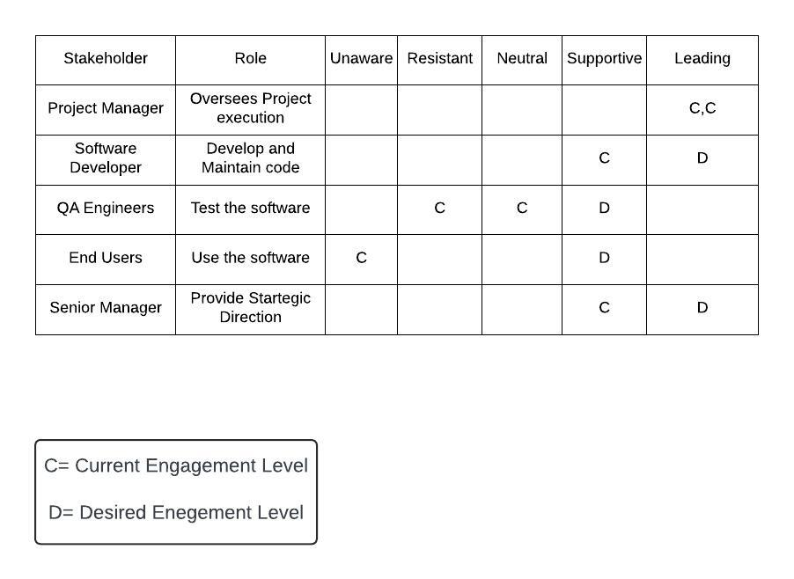

Engagement level diagram.

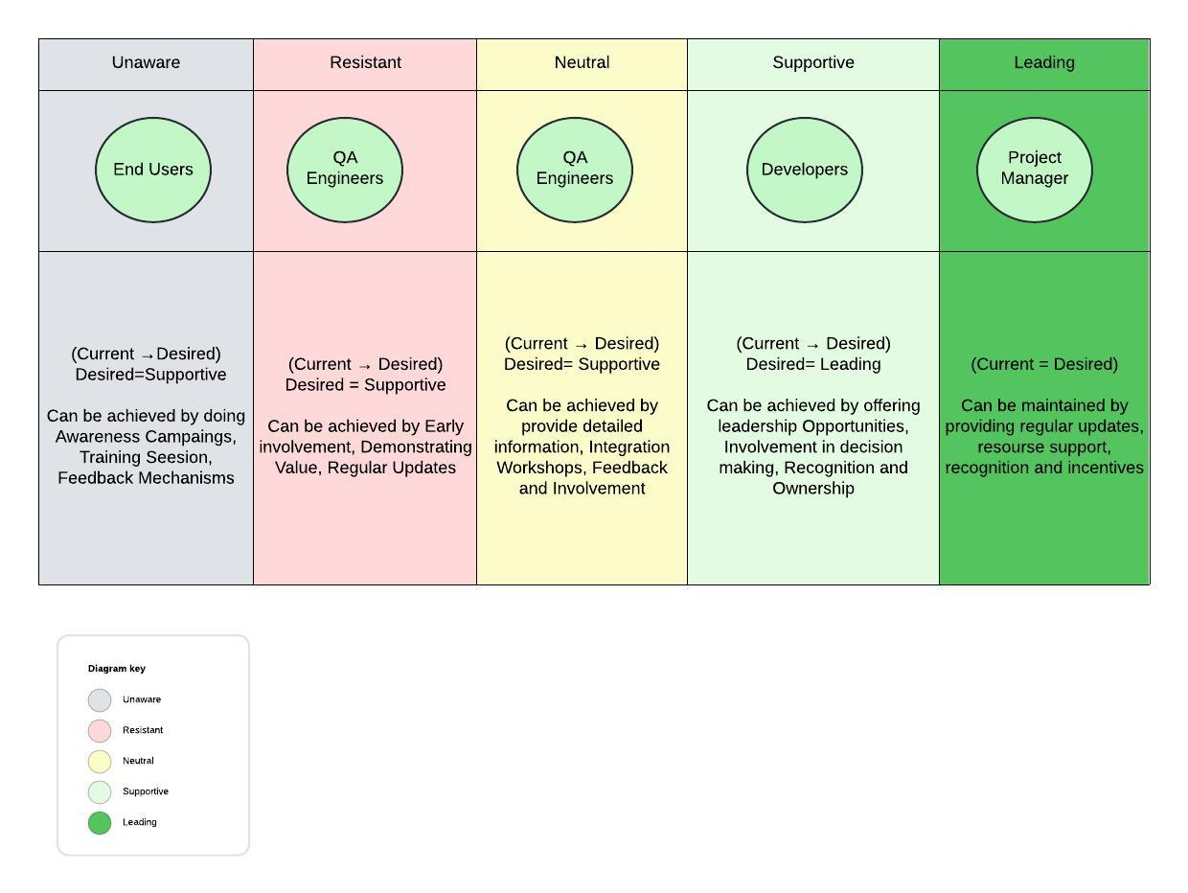

Use Case Study for Each Engagement Level

1. Unaware
- Stakeholder: End Users
- Current Engagement Level: Unaware
- Desired Engagement Level: Supportive
Use Case:
- Situation: End users, such as customers or internal employees who will interact with the software, are currently unaware of the new predictive model project. They are not informed about the project's goals, benefits, or potential impacts on their user experience.
- Reason for Engagement Level: End users may be unaware because the project is in its early stages or because communication about the project has not yet reached them. There may be a lack of direct communication channels between the project team and the end users.
- Strategy to Increase Engagement:
  - Awareness Campaigns: Initiate an awareness campaign using emails, intranet announcements, or workshops to inform end users about the project.
  - Training Sessions: Conduct training sessions that explain the benefits of the predictive model and how it will enhance their experience.
  - Feedback Mechanisms: Establish feedback mechanisms to understand users’ concerns or suggestions, ensuring they feel included in the process.

2. Resistant
- Stakeholder: QA Engineers
- Current Engagement Level: Resistant
- Desired Engagement Level: Supportive
Use Case:
- Situation: QA Engineers might be resistant to the project because they perceive it as an additional burden or a disruption to their current testing processes. They may fear that the new model will increase their workload or make their role redundant.
- Reason for Engagement Level: Resistance may stem from a lack of involvement in the project’s early stages, concerns about job security, or doubts about the project's value to their work.
- Strategy to Increase Engagement:
  - Early Involvement: Involve QA Engineers early in the development process, allowing them to contribute to decision-making and provide input on how the model can be integrated into their workflow.
  - Demonstrating Value: Show how the model can streamline testing processes, identify potential issues earlier, and improve overall software quality, thus enhancing their role rather than diminishing it.
  - Regular Updates: Keep them informed about project progress and any changes that may affect their work, building trust and reducing resistance.

3. Neutral
- Stakeholder: QA Engineers
- Current Engagement Level: Neutral
- Desired Engagement Level: Supportive
Use Case:
- Situation: QA Engineers are aware of the project but do not have strong opinions for or against it. They may be waiting to see how the project evolves before forming an opinion.
- Reason for Engagement Level: Neutrality could be due to a lack of detailed information about the project or because their roles have not yet been significantly impacted.
- Strategy to Increase Engagement:
  - Detailed Information: Provide QA Engineers with comprehensive information about the project, including its benefits and how it aligns with their work.
  - Integration Workshops: Conduct workshops to demonstrate how the model integrates with their current testing processes, emphasizing ease of use and potential time savings.
  - Feedback and Involvement: Encourage regular feedback and involve them in periodic reviews to keep them engaged and progressively more supportive.

4. Supportive
- Stakeholder: Software Developers
- Current Engagement Level: Supportive
- Desired Engagement Level: Leading
Use Case:
- Situation: Software Developers are currently supportive of the project and understand its potential benefits. They see the value in the predictive model and are positive about its implementation.
- Reason for Engagement Level: Developers often have a strong technical understanding of the project and can see how it will improve software quality and efficiency. Their technical background makes them naturally inclined to support innovative solutions.
- Strategy to Increase Engagement:
  - Leadership Opportunities: Offer developers leadership roles in sub-teams or specific tasks related to the project, such as model implementation or code reviews.
  - Involvement in Decision-Making: Involve them in key decision-making processes, allowing them to influence the project's direction and outcomes.
  - Recognition and Ownership: Recognize their contributions and give them ownership of certain aspects of the project, empowering them to lead and drive success.

5. Leading
- Stakeholder: Project Manager
- Current Engagement Level: Leading
- Desired Engagement Level: Leading
Use Case:
- Situation: The Project Manager is actively engaged in the project, ensuring that all aspects are running smoothly and that the project stays on track. They are deeply involved in planning, resource allocation, and stakeholder management.
- Reason for Engagement Level: The Project Manager is responsible for the project's overall success, which naturally places them in a leading role. Their involvement is critical to coordinating the efforts of all other stakeholders.
- Strategy to Maintain Engagement:
  - Regular Progress Updates: Hold regular meetings to review project progress, address any challenges, and make necessary adjustments.
  - Resource Support: Ensure the Project Manager has all the resources, information, and support needed to manage the project effectively.
  - Recognition and Incentives: Recognize their leadership and offer incentives or professional development opportunities to maintain their motivation and engagement.

Project Plan- (Environmental Variables, Scope, Organizational Systems)

Project Management Plan for the Design and Implementation of a Software Life Expectancy Model

1. Project Overview
- Project Name: Design and Implementation of a Software Life Expectancy Model
- Project Manager: Tripti Vishwakarma
- Start Date: Aug-05 -2024
- End Date: Dec-08-2024
- Project Sponsor: XYZ Software Solutions
- Budget: $150,000

2. Project Objectives
- Develop a predictive model to estimate the life expectancy of the software.
- Integrate the model with the existing software program.
- Validate the model's accuracy through testing and real-world data.
- Provide comprehensive documentation and training for stakeholders on using the model.

3. Environment Variables

Organizational Environment Variables:
- Culture and Structure: Collaborative culture, flat organizational structure.
- Resource Availability: Skilled personnel, technology, financial resources.
- Policies and Procedures: Data security policies, project management methodologies.

External Environment Variables:
- Market Conditions: Customer preferences, competitor activities.
- Regulatory Requirements: Compliance with data protection laws.
- Technological Advances: Staying updated with technological trends.

Project-Specific Environment Variables:
- Stakeholder Expectations: Regular communication and feedback loops.
- Project Complexity: Number of deliverables, interdependencies.

4. Scope Processes

Defining Scope:
- Scope Statement: Outlines project objectives, deliverables, and boundaries.
- Work Breakdown Structure (WBS): Hierarchical view of project deliverables.
Validating Scope:
- Scope Validation: Formal acceptance of completed deliverables from stakeholders.
Controlling Scope:
- Scope Control: Monitoring progress and managing changes to the scope.

5. Organizational Systems
Project Management Methodologies:
- Agile Methodology: Iterative development, regular feedback, flexibility.
- Waterfall Methodology: Linear, sequential approach for well-defined requirements.
Communication Tools:
- Collaboration Platforms: Slack, Microsoft Teams.
- Project Management Software: Jira, Trello.
Information Systems:
- Document Management Systems: Confluence, SharePoint.
- Data Analytics Tools: Python, R, Google Analytics.

6. Project Timeline

Phase | Start Date | End Date | Duration
Project Initiation | Aug-05-2024 | Aug-11-2024 | 1 week
Requirements Gathering | Aug-12-2024 | Aug-25-2024 | 2 weeks
Design | Aug-26-2024 | Sep-08-2024 | 2 weeks
Development | Sep-09-2024 | Oct-20-2024 | 6 weeks
Integration | Oct-21-2024 | Nov-03-2024 | 2 weeks
Testing Validation | Nov-04-2024 | Nov-17-2024 | 2 weeks
Documentation and Training | Nov-18-2024 | Dec-01-2024 | 2 weeks
Project Closure | Dec-02-2024 | Dec-08-2024 | 1 week

Project Team:

- Project Manager: Tripti Vishwakarma
- Business Analyst: Jane Dwen
- Data Scientist: John Smith
- Software Developer: Alice Johnson
- QA Tester: Bob Brown
- Technical Writer: Carol White
- Trainer: Dave Green

Tools and Technologies:
- Project Management Software (e.g., Jira, Trello)
- Data Analysis Tools (e.g., Python, R)
- Development Environment (e.g., Visual Studio, Eclipse)
- Version Control System (e.g., Git)
- Testing Tools (e.g., Selenium, JUnit)
- Documentation Tools (e.g., Confluence, MS Word)

8. Risk Management
Risk Identification:
- Inaccurate requirements leading to model inaccuracies.
- Integration issues with the existing software program.
- Delays in development due to unforeseen technical challenges.
- Insufficient data for model validation.
Risk Mitigation:
- Conduct thorough requirements analysis and validation with stakeholders.
- Plan for iterative integration and testing phases.
- Allocate buffer time in the project schedule for potential delays.
- Use synthetic data and historical data for initial model validation.

9. Communication Plan

Stakeholder Communication:
- Weekly status meetings with the project team.
- Bi-weekly progress reports to stakeholders.
- Monthly review meetings with senior management.
- Ad-hoc meetings as needed for issue resolution.

Communication Channels:
- Email for formal communication and documentation sharing.
- Slack or Microsoft Teams for real-time communication and collaboration.
- Jira or Trello for task tracking and project management.
- Confluence or SharePoint for documentation and knowledge sharing.

10. Project Closure

Activities:
- Finalize all project deliverables and obtain stakeholder approval.
- Conduct a post-project review to identify lessons learned.
- Archive project documentation and materials.
- Release project resources and formally close the project.

Initial Project plan design using Lucidchart-

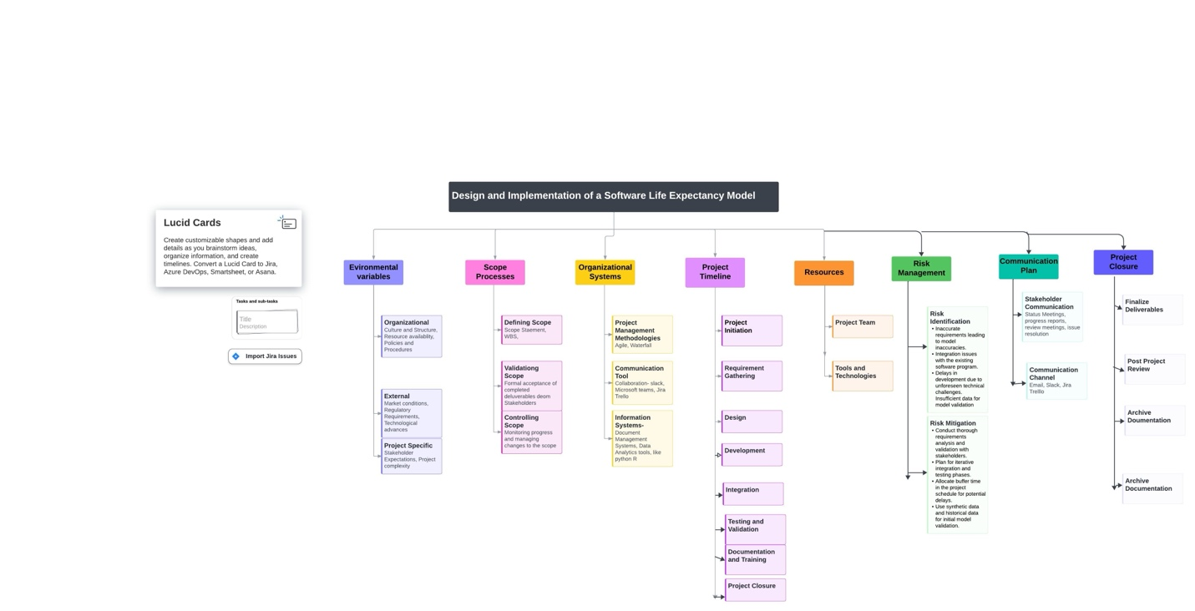

Initial Work Breakdown Structure (WBS) Its Role in the Overall Process
for the Software Life Expectancy Model Project

In my project, the WBS will serve as a foundational tool that guides the entire project lifecycle, from planning to execution and closure. Here’s how it will work in the overall process:

1. Defining Scope
In my project, the WBS will help in clearly defining the scope by breaking down the project into smaller, manageable components. This hierarchical structure will ensure that all project deliverables are identified and detailed.
- Process: The project team will create a WBS that outlines all major deliverables, such as model development, integration, testing, and documentation. Each deliverable will be further broken down into sub-tasks, providing a comprehensive view of the project scope.

2. Resource Allocation
The WBS will be instrumental in identifying the resources required for each task, including personnel, technology, and financial resources. This will facilitate efficient resource allocation and ensure that each task has the necessary support.
- Process: Using the WBS, the project manager will allocate resources based on the specific requirements of each task. For example, data scientists will be assigned to model development tasks, while QA testers will focus on testing and validation.

3. Scheduling
The WBS will provide a framework for developing a detailed project schedule. By identifying task dependencies and sequences, the WBS will help in creating a realistic timeline and setting milestones.
- Process: The project manager will use the WBS to develop a project timeline, outlining the start and end dates for each task. Milestones will be established to track progress and ensure timely completion of deliverables.

4. Risk Management
The WBS will play a crucial role in identifying potential risks associated with each task. This will allow the project team to develop mitigation strategies and contingency plans to address these risks proactively.
- Process: The project team will conduct a risk assessment based on the WBS, identifying risks such as integration issues or data inaccuracies. Mitigation strategies, such as iterative testing and validation, will be incorporated into the project plan.

5. Monitoring and Controlling
The WBS will serve as a baseline for monitoring project progress. By comparing actual performance against the WBS, the project manager can identify deviations and take corrective actions to keep the project on track.
- Process: The project manager will use the WBS to track the progress of each task. Regular status meetings will be held to review progress, and any deviations from the plan will be addressed promptly.

6. Communication
The WBS will enhance communication by providing a common understanding of the project scope and tasks among all stakeholders. This will ensure that everyone is aligned with the project objectives and deliverables.
- Process: The project team will use the WBS to communicate the project plan to stakeholders. Regular updates will be provided based on the WBS, ensuring that stakeholders are kept informed of the project’s progress.

7. Documentation and Training
The WBS will help in organizing and structuring the documentation and training materials. This will ensure that all aspects of the project are covered comprehensively.
- Process: The technical writer will use the WBS to create detailed documentation for the project, covering all deliverables and tasks. The trainer will develop training materials based on the WBS, ensuring that stakeholders are well-prepared to use the Software Life Expectancy Model.

8. Project Closure
The WBS will provide a clear outline of the final deliverables and tasks that need to be completed for project closure. This will ensure that all aspects of the project are finalized and approved by stakeholders.
- Process: The project manager will use the WBS to finalize all deliverables, ensuring that each task is completed and approved by stakeholders. A post-project review will be conducted based on the WBS, identifying lessons learned and areas for improvement.

Project Design and Outline

Project Plan for the Design and Outline of a Software Life Expectancy Model

1. Project Overview
- Project Name: Design and Implementation of a Software Life Expectancy Model
- Project Manager: Tripti Vishwakarma
- Start Date: September 15, 2024
- End Date: January 19, 2025
- Project Sponsor: XYZ Software Solutions
- Budget: $150,000

2. Project Objectives
- Develop a predictive model to estimate the software’s life expectancy.
- Integrate the model with the existing software program.
- Validate the model's accuracy through testing and real-world data.
- Provide comprehensive documentation and training for stakeholders.

3. Scope
- Project Scope:
  - Model Development: Create a predictive model using historical and real-time data.
  - Integration: Embed the model into the current software ecosystem.
  - Testing and Validation: Conduct rigorous testing and validation to ensure accuracy.
  - Documentation and Training: Prepare detailed documentation and provide training sessions for stakeholders.

4. Budget
- Total Budget: $150,000
Category | Estimated Cost
Personnel | $80,000
Software and Tools | $20,000
Training and Documentation | $15,000
Contingency | $10,000
Miscellaneous | $25,000
Total | $150,000
5. Resources
- Personnel:
  - Project Manager: Tripti Vishwakarma
  - Business Analyst: Jane Dwen
  - Data Scientist: John Smith
  - Software Developer: Alice Johnson
  - QA Tester: Bob Brown
  - Technical Writer: Carol White
  - Trainer: Dave Green

- Tools and Technologies:
  - Project Management Software: Jira, Trello
  - Data Analysis Tools: Python, R
  - Development Environment: Visual Studio, Eclipse
  - Version Control System: Git
  - Testing Tools: Selenium, JUnit
  - Documentation Tools: Confluence, MS Word

6. Stakeholder Analysis
- Primary Stakeholders:
  - XYZ Software Solutions: Project sponsor providing overall direction and funding.
  - End Users: Users of the software who will benefit from the life expectancy model.
  - Development Team: Responsible for implementing and integrating the model.
- Secondary Stakeholders:
  - Regulatory Bodies: Ensure compliance with data protection laws.
  - Training Participants: Receive training on the new model and documentation.

7. Project Timeline
Phase | Start Date | End Date | Duration
Project Initiation | Sep 15, 2024 | Sep 21, 2024 | 1 week
Requirements Gathering | Sep 22, 2024 | Oct 5, 2024 | 2 weeks
Design | Oct 6, 2024 | Oct 19, 2024 | 2 weeks
Development | Oct 20, 2024 | Dec 1, 2024 | 6 weeks
Integration | Dec 2, 2024 | Dec 15, 2024 | 2 weeks
Testing & Validation | Dec 16, 2024 | Dec 29, 2024 | 2 weeks
Documentation & Training | Dec 30, 2024 | Jan 12, 2025 | 2 weeks
Project Closure | Jan 13, 2025 | Jan 19, 2025 | 1 week

8. Possible Change Requests and Goal Alignments
- Change Requests:
  - Scope Changes: Adjustments in model complexity or additional features.
  - Budget Adjustments: Reallocation due to unforeseen expenses or additional requirements.
  - Timeline Modifications: Shifts in deadlines due to development or integration challenges.

- Goal Alignments:
  - Review Meetings: Regular meetings with stakeholders to ensure alignment with objectives and manage expectations.
  - Scope Management: Formal change control procedures to address scope changes and align with overall project goals.

9. Project Management Approach
- Methodologies:
  - Agile Methodology: For iterative development and flexibility.
  - Waterfall Methodology: For phases with well-defined requirements.
- Communication Plan:
  - Weekly Status Meetings: With the project team.
  - Bi-weekly Progress Reports: To stakeholders.
  - Monthly Review Meetings: With senior management.
  - Ad-hoc Meetings: For urgent issue resolution.
- Risk Management:
  - Risk Identification: Issues related to requirements, integration, technical challenges, and data availability.
  - Risk Mitigation: Thorough requirements analysis, iterative testing, buffer time allocation, and data validation strategies.
10. Project Closure
- Activities:
  - Finalize Deliverables: Ensure all deliverables meet stakeholder expectations and obtain formal approval.
  - Post-Project Review: Conduct a review to capture lessons learned and areas for improvement.
  - Documentation: Archive all project documentation and materials.
  - Resource Release: Release project resources and formally close the project.

Diagrams and Charts

- Work Breakdown Structure (WBS): Visual representation of project deliverables and tasks.

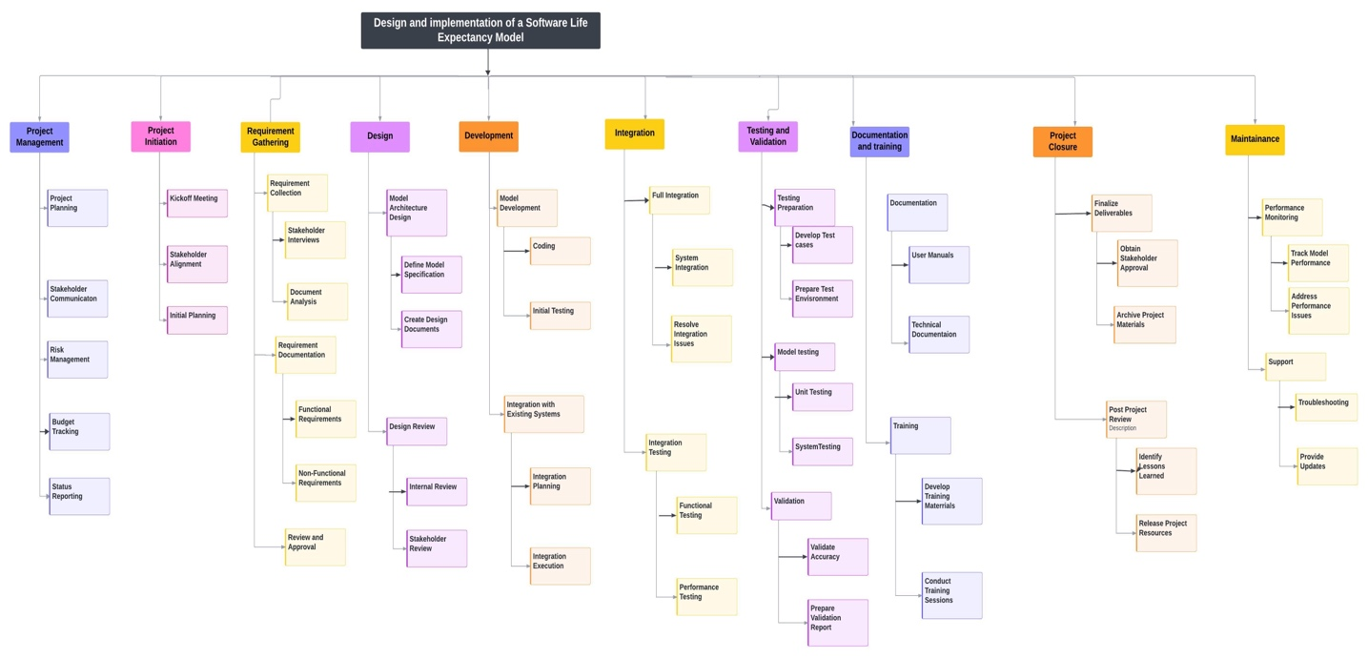

- Gantt Chart: Timeline visualization of project phases and milestones.

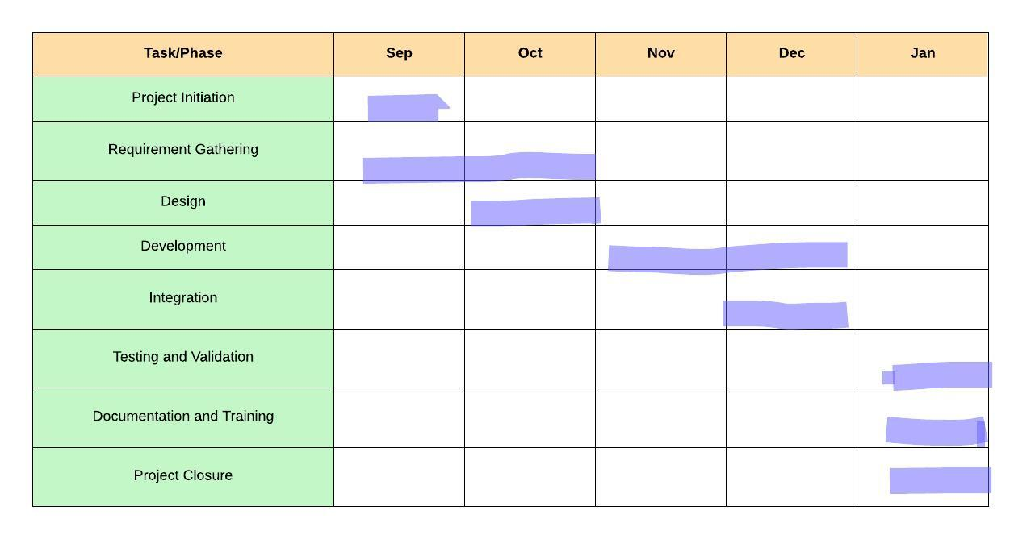

Project Outline

Project Name: Design and Implementation of a Software Life Expectancy Model
Project Manager: Tripti Vishwakarma
Start Date: September 15, 2024
End Date: January 19, 2025
Budget: $150,000

1. Project Scope
Objectives:
- Develop a predictive model to estimate software life expectancy.
- Integrate the model with the existing software systems.
- Validate the model’s accuracy with real-world data.
- Provide comprehensive documentation and training for stakeholders.
Deliverables:
- Predictive Model: Functional model for estimating software life expectancy.
- Integration: Model integrated with existing software systems.
- Validation Report: Documentation of testing and validation results.
- Documentation: Manuals, technical documentation, training materials.
- Training: Training sessions and workshops for stakeholders.
Out of Scope:
- Major software updates beyond integration.
- Long-term support beyond initial training and documentation.

2. Project Timeline
Phase 1: Project Initiation
- Start Date: September 15, 2024
- End Date: September 21, 2024
- Duration: 1 week
- Activities: Kickoff meeting, stakeholder alignment, initial planning.
Phase 2: Requirements Gathering
- Start Date: September 22, 2024
- End Date: October 5, 2024
- Duration: 2 weeks
- Activities: Collect and document requirements, stakeholder interviews.
Phase 3: Design
- Start Date: October 6, 2024
- End Date: October 19, 2024
- Duration: 2 weeks
- Activities: Design model architecture, create design specifications.
Phase 4: Development
- Start Date: October 20, 2024
- End Date: December 1, 2024
- Duration: 6 weeks
- Activities: Develop predictive model, initial integration with systems.
Phase 5: Integration
- Start Date: December 2, 2024
- End Date: December 15, 2024
- Duration: 2 weeks
- Activities: Complete model integration, resolve issues.
Phase 6: Testing & Validation
- Start Date: December 16, 2024
- End Date: December 29, 2024
- Duration: 2 weeks
- Activities: Conduct tests, validate accuracy, prepare report.
Phase 7: Documentation & Training
- Start Date: December 30, 2024
- End Date: January 12, 2025
- Duration: 2 weeks
- Activities: Prepare documentation, conduct training sessions.
Phase 8: Project Closure
- Start Date: January 13, 2025
- End Date: January 19, 2025
- Duration: 1 week
- Activities: Finalize deliverables, obtain approval, conduct review.
Maintenance Phase:
- Start Date: January 20, 2025
- End Date: TBD
- Activities: Monitor performance, provide support, address issues.

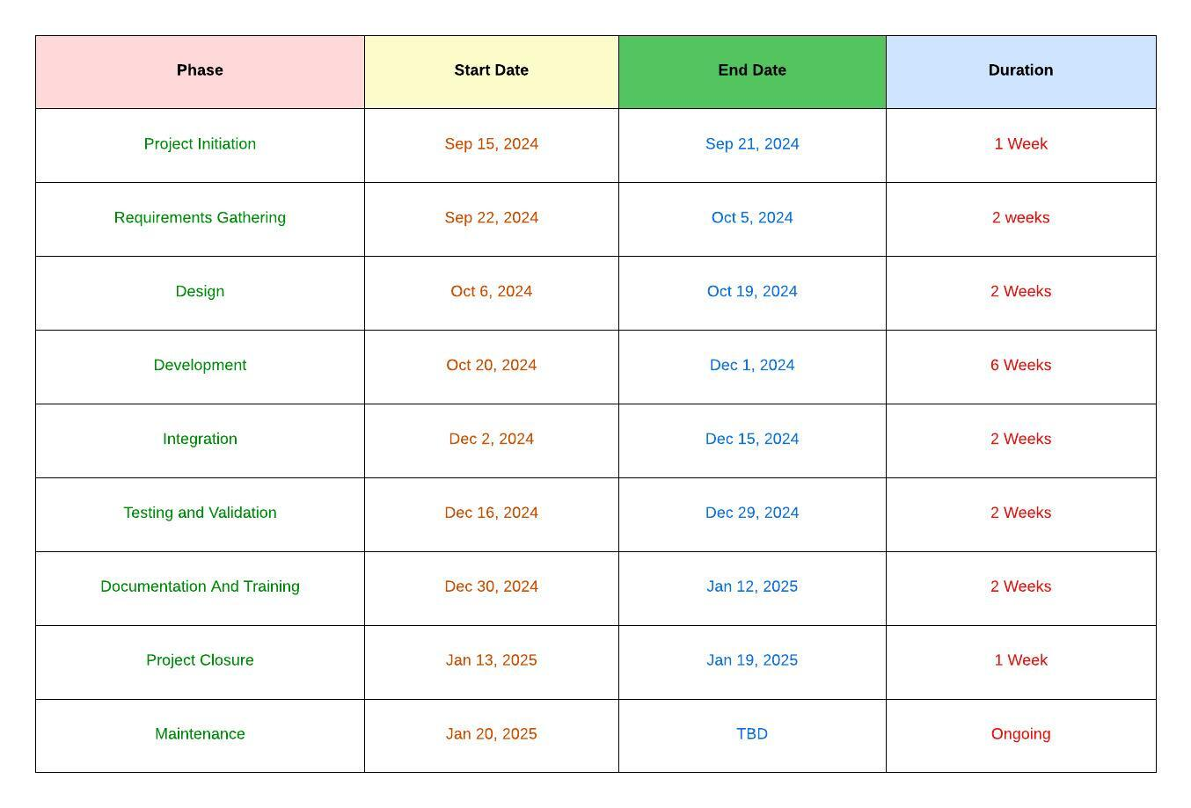

Notes:
- Change Requests: Any changes in scope or timelines will follow a formal change management process.
- Goal Alignment: Regular reviews will ensure alignment with project objectives and stakeholder expectations.

Project Design and Outline

Outline of Processes Required for Design Methodology

Project Name: Design and Implementation of a Software Life Expectancy Model
Project Manager: Tripti Vishwakarma
Start Date: September 15, 2024
End Date: January 19, 2025
Budget: $150,000

1. Project Scope

Objectives:
- Develop a predictive model to estimate software life expectancy.
- Integrate the model with the existing software systems.
- Validate the model’s accuracy with real-world data.
- Provide comprehensive documentation and training for stakeholders.

Deliverables:
- Predictive Model: Functional model for estimating software life expectancy.
- Integration: Model integrated with existing software systems.
- Validation Report: Documentation of testing and validation results.
- Documentation: Manuals, technical documentation, training materials.
- Training: Training sessions and workshops for stakeholders.

Out of Scope:
- Major software updates beyond integration.
- Long-term support beyond initial training and documentation.

2. Project Timeline

Phase 1: Project Initiation

- Start Date: September 15, 2024
- End Date: September 21, 2024
- Duration: 1 week
- Activities: Kickoff meeting, stakeholder alignment, initial planning.

Phase 2: Requirements Gathering

- Start Date: September 22, 2024
- End Date: October 5, 2024
- Duration: 2 weeks
- Activities: Collect and document requirements, stakeholder interviews.

Phase 3: Design
- Start Date: October 6, 2024
- End Date: October 19, 2024
- Duration: 2 weeks
- Activities: Design model architecture, create design specifications.

Phase 4: Development
- Start Date: October 20, 2024
- End Date: December 1, 2024
- Duration: 6 weeks
- Activities: Develop predictive model, initial integration with systems.

Phase 5: Integration
- Start Date: December 2, 2024
- End Date: December 15, 2024
- Duration: 2 weeks
- Activities: Complete model integration, resolve issues.

Phase 6: Testing & Validation
- Start Date: December 16, 2024
- End Date: December 29, 2024
- Duration: 2 weeks
- Activities: Conduct tests, validate accuracy, prepare report.

Phase 7: Documentation & Training
- Start Date: December 30, 2024
- End Date: January 12, 2025
- Duration: 2 weeks
- Activities: Prepare documentation, conduct training sessions.

Phase 8: Project Closure
- Start Date: January 13, 2025
- End Date: January 19, 2025
- Duration: 1 week
- Activities: Finalize deliverables, obtain approval, conduct review.

3. Design Methodology Processes

3.1 Requirements Gathering
- Objective: Collect and document all necessary requirements from stakeholders.
- Activities:
  - Conduct stakeholder interviews.
  - Review existing documentation and systems.
  - Create a requirements specification document.
- Tools: Jira, Confluence, MS Word.

3.2 Design
- Objective: Develop a detailed design for the predictive model and its integration.
- Activities:
  - Design model architecture.
  - Create design specifications and diagrams.
  - Review design with stakeholders for feedback.
- Tools: Visual Studio, Eclipse, MS Visio.

3.3 Development
- Objective: Develop the predictive model and integrate it with existing systems.
- Activities:
  - Code the predictive model using Python or R.
  - Integrate the model with the existing software.
  - Conduct unit testing to ensure functionality.
- Tools: Python, R, Git, Visual Studio.

3.4 Integration
- Objective: Ensure the predictive model is fully integrated and functional within the existing software ecosystem.
- Activities:
  - Complete integration tasks.
  - Resolve any integration issues.
  - Conduct integration testing.
- Tools: Git, Jenkins, Selenium.

3.5 Testing & Validation
- Objective: Validate the accuracy and reliability of the predictive model.
- Activities:
  - Develop test cases and scenarios.
  - Conduct testing using real-world data.
  - Document and analyze test results.
- Tools: Selenium, JUnit, MS Excel.

3.6 Documentation & Training
- Objective: Provide comprehensive documentation and training for stakeholders.
- Activities:
  - Prepare user manuals and technical documentation.
  - Conduct training sessions and workshops.
  - Gather feedback and make necessary adjustments.
- Tools: Confluence, MS Word, PowerPoint.

3.7 Project Closure
- Objective: Finalize the project and ensure all deliverables meet stakeholder expectations.
- Activities:
  - Finalize and deliver all project documentation.
  - Conduct a post-project review to capture lessons learned.
  - Release project resources and formally close the project.
- Tools: Jira, Confluence, MS Word.

Gantt Chart-

Below is a manually created Gantt chart for the project timeline. This chart provides a visual representation of the project phases and milestones.

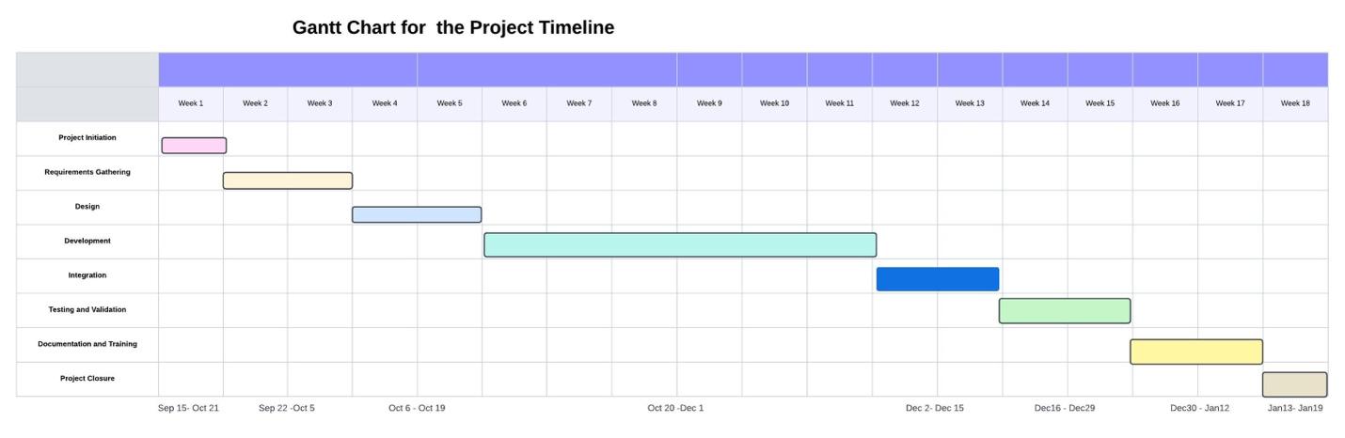

The design and implementation of a software life expectancy model is a complex project that requires careful planning and execution. By following a structured design methodology, the project team can ensure that the model meets all requirements, integrates seamlessly with existing systems, and provides value to stakeholders. The attached Gantt chart provides a visual representation of the project timeline, highlighting key phases and milestones.

Risk Management

Risk Matrix for Project: Implementing and Design of Software Life Expectancy Model

Probability and Impact Definitions:

- Probability: Low, Medium, High
- Impact: Minor, Moderate, Severe, Catastrophic

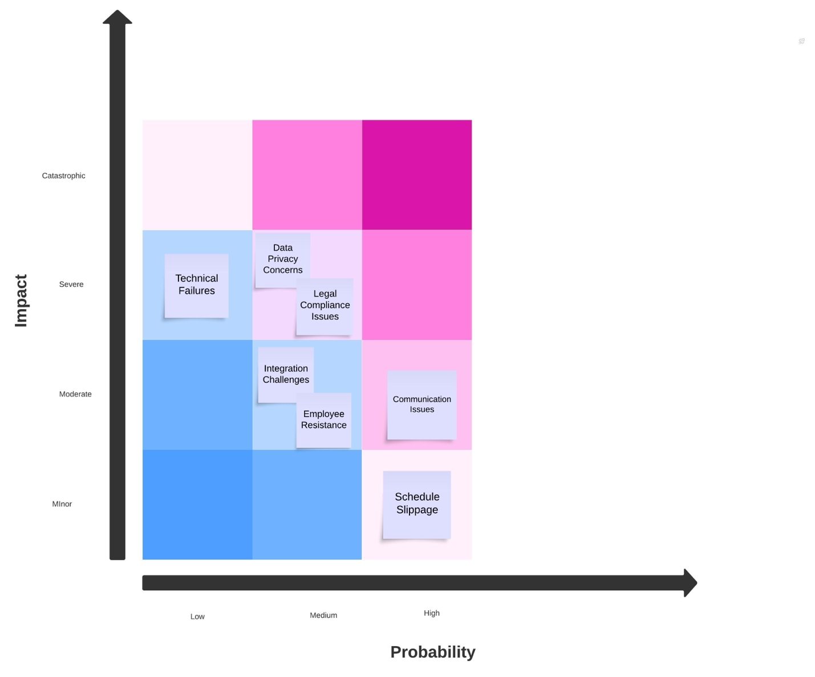

Identified Risks:

- Communication Issues
  - Probability: High
  - Impact : Moderate
  - Risk: High

- Data Privacy Concerns
  - Probability: Medium
  - Impact : Severe
  - Risk: High

- Integration Challenges
  - Probability: Medium
  - Impact : Moderate
  - Risk: Medium

- Technical Failures
  - Probability: Low
  - Impact : Severe
  - Risk: Medium

- Schedule Slippage
  - Probability: High
  - Impact : Minor
  - Risk: Medium

- Legal Compliance Issues
  - Probability: Medium
  - Impact : Severe
  - Risk: High

- Employee Resistance
  - Probability: Medium
  - Impact : Moderate
  - Risk: Medium

Synopsis of Potential Scenarios:

- Communication Issues
  - Potential to Occur: High likelihood due to the large workforce and complexity of the project.
  - Possible Fallout: Misalignment of project goals, delays in deliverables, and reduced project efficiency.

- Data Privacy Concerns
  - Potential to Occur: Medium likelihood due to handling sensitive data.
  - Possible Fallout: Legal repercussions, loss of stakeholder trust, and potential financial penalties.

- Integration Challenges
  - Potential to Occur: Medium likelihood due to the complexity of integrating new models with existing systems.
  - Possible Fallout: Delays in project timeline, increased costs, and potential system downtimes.

- Technical Failures
  - Potential to Occur: Low likelihood with proper testing and validation.
  - Possible Fallout: Severe impact on project deliverables, requiring rework and additional resources.

- Schedule Slippage
  - Potential to Occur: High likelihood due to the project's complexity and potential unforeseen issues.
  - Possible Fallout: Minor impact if managed well but could lead to stakeholder dissatisfaction if not communicated properly.

- Legal Compliance Issues
  - Potential to Occur: Medium likelihood due to the need for compliance with data protection laws.
  - Possible Fallout: Severe legal and financial consequences, project delays, and potential rework.

- Employee Resistance
  - Potential to Occur: Medium likelihood due to changes in processes and systems.
  - Possible Fallout: Decreased productivity, postponements in project phases, and the possible requirement for extra training and change management initiatives.

Risk Mitigation-

- Communication Issues: Given the large workforce, it's essential to establish clear communication channels and protocols. Regular updates and feedback loops can help ensure everyone is on the same page.

- Data Privacy Concerns: Managing sensitive data necessitates rigorous compliance with data protection regulations. Regular training on data privacy for all team members can help mitigate risks.

- Integration Challenges: Integration with existing systems can be complex. Detailed planning and phased integration can help manage this risk.

- Technical Failures: Ensuring robust testing and validation processes can minimize the likelihood of technical failures. Regular maintenance and updates can also help.

- Schedule Slippage: Building in buffer time and regularly reviewing progress can help manage schedule slippage. Clear communication with stakeholders about any delays is crucial.

- Legal Compliance Issues: Regular consultations with legal experts and compliance audits can help ensure adherence to relevant laws and regulations.

- Employee Resistance: Change management strategies, including training and open communication, can help address employee resistance and ensure smooth transitions

By actively recognizing and addressing these risks, the team of this project can better navigate challenges and ensure the project's successful deployment.

Final Project Outline:

The project outline consolidates all the information into a single document that serves as a roadmap for the project. It includes a detailed project scope, timeline, risk management strategies, and a communication plan. This outline ensures that everyone involved in the project has a clear understanding of the objectives, deliverables, and their roles in achieving success.

By following this comprehensive plan, the project team can ensure that the Software Life Expectancy Model is developed, tested, and deployed successfully, providing valuable insights to stakeholders and contributing to better decision-making in software management.

References-

    - National Institute of Standards and Technology (NIST). Framework for improving critical infrastructure cybersecurity https://nvlpubs.nist.gov/nistpubs/CSWP/NIST.CSWP.04162018.pdf

    - European Commission (2020), General Data Protection Regulation (GDPR). https://ec.europa.eu/info/law/law-topic/data-protection_en

    - PMBOK® Guide – Seventh Edition https://www.pmi.org/pmbok-guide-standards/foundational/pmbok

    - 24FA-CSC501-2[Based on Project Management Professional (PMP) Based on PMBOK7] https://seu-csuglobal.ucertify.com/app/?func=ebook&chapter_no=14#07ruW

    - Meredith, J. R., Shafer, S. M., & Mantel, S. J. (2017). Project Management: A Managerial Approach (10th ed.). Wiley.

    - Pinto, J. K. (2019). Project Management: Achieving Competitive Advantage (5th ed.). Pearson.
    - PMI. (2021). A Guide to the Project Management Body of Knowledge (PMBOK Guide). Project Management Institute.

    - Kerzner, H. (2019). Project Management: A Systems Approach to Planning, Scheduling, and Controlling. Wiley.
    - Fisher, R., & Ury, W. (1981). Getting to Yes: Negotiating Agreement Without Giving In. Penguin Books.

    - "The Work Breakdown Structure: A Brief Synopsis" Webster, F. M. (1994). The WBS. PM Network, 8(12), 40–46.
    - https://www.pmi.org/learning/library/work-breakdown-structure-basic-principles-4883#:~:text=Work%20Breakdown%20Structure%20%28WBS%29%3A%20a%20product-oriented%20“family%20tree”,component.%20Project%20components%20may%20be%20products%20or%20services.

    - Software Engineering: A Practitioner's Approach by Roger S. Pressman
    - https://platform.virdocs.com/read/1490446/200/#/4/4

    - Software Maintenance: Concepts and Practice" by Penny Grubb and Armstrong A. Takang
    - https://books.google.com/books?id=ge8o_VkAsiYC&printsec=frontcover&source=gbs_ge_summary_r&cad=0#v=onepage&q&f=false

    - Becoming a PMP® Certified Professional: A Study Guide to Mastering Project Management for the PMP® Exam, Author: J. Ashley Hunt
    - https://eds-p-ebscohost-com.csuglobal.idm.oclc.org/eds/ebookviewer/ebook/bmxlYmtfXzI3NjIxMTRfX0FO0?sid=ca959cc0-83bb-4fb9-b146-56d8ab0b3764@redis&vid=1&format=EB&lpid=lp_3&rid=0

